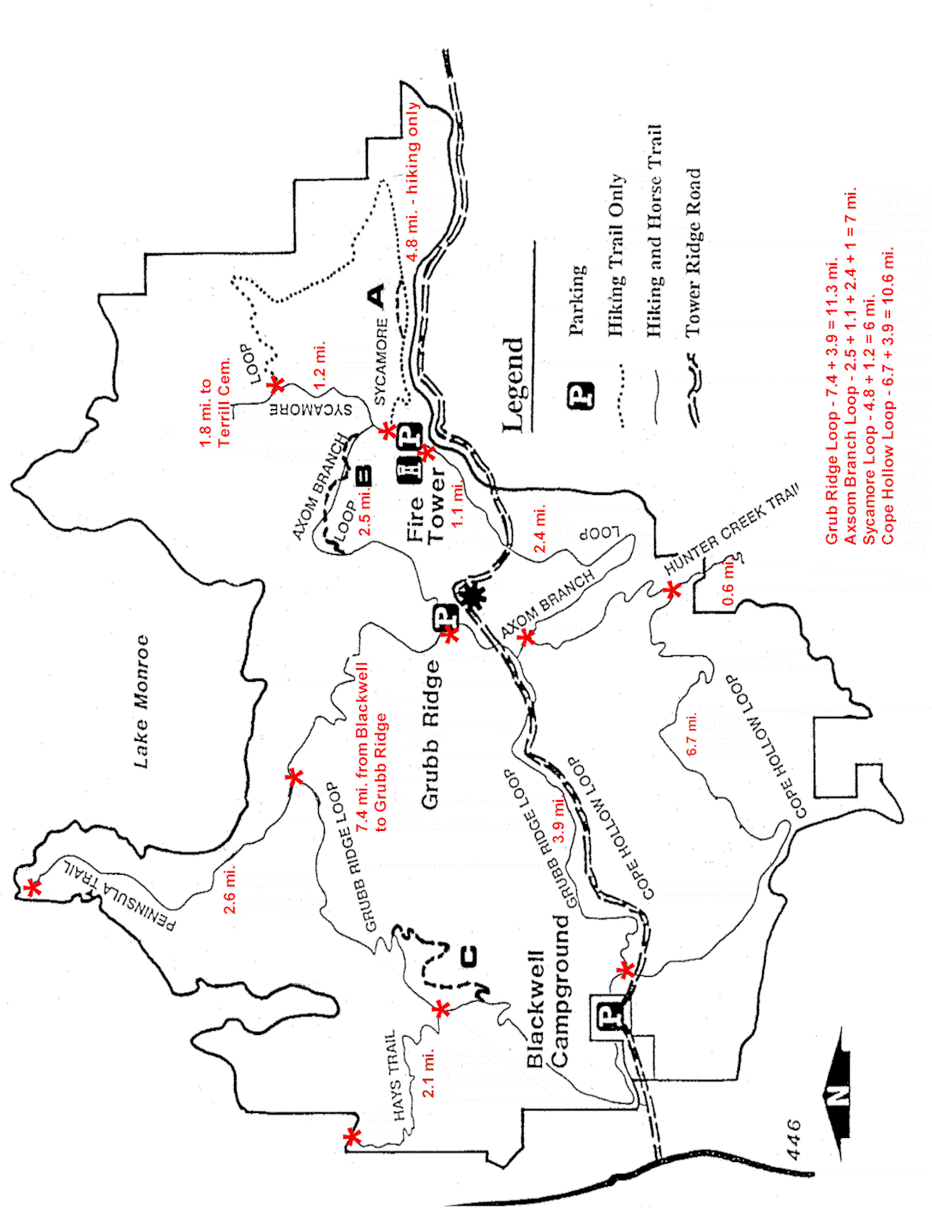

Exodus journey
Survival guide
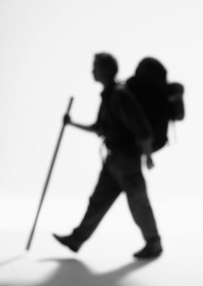
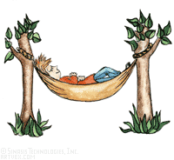
CCBCi Exodus Journey
Equipment Check List

Clothing:

- Minimal Undergarments
- Warm hat for Night
- Gloves (not large ski)
- Long Underwear
- Long Pants (1) no jeans
- Hat for Day
- T-shirt (2)
- Sweater
- Warm Jacket
- Shorts (2)
- Hiking Boots / Socks
Merino Wool is warm! – Layering is most efficient for warmth!
- Bandana or Handkerchief
- Rain Poncho or Suit
- Wind Breaker
- Sunglasses

CCBCi Essentials:

- 3-4 One Quart Size Water Bottles
- 4 Trash Bags (Large Lawn)
- Spoon / Fork
- Cup
- Bowl
- Pocket Knife (small)
- Tooth Brush / Paste (travel size)
- Personal First Aid Kit / Hand Sanitizer
- Baby Wipes
- 100 ft. Cord / Rope
- Lighter
- Flashlight (small) – w/ extra batteries & bulb
- Bible (small) and Journal / Pen (small)
- Whistle
- 3 One Gallon Zip Lock Bags
- Moleskin

Main Equipment:
- Framed Backpack (No weekend or child packs. Greater than 55 liters)
- Sleeping Bag (40 or colder, No cloth bags or Spring Bags)
- Camping Hammock and Rain Fly or 1 Small Tarp (5’x7’ or 8’x8’)
OR 2 Small Tarps (5’x7’ or 6’x8’)
- Insulated Pad (Foam or Self Insulating)
These Items should be borrowed or rented if you don’t already own or have good equipment!
Places to purchase equipment:

- REI
Castleton Corner Dr.
8490 E. 82nd Street
Indianapolis, IN 46250
- Gander Mountain
5702 East 86th St
Indianapolis, IN 46250
- Dicks Sporting Goods
Castleton Square Mall
- Amazon.com
Optional:
- Compass
- Camera
- Comb (for long hair)
- Camp Shoes (light & small)
- Chair (compact & light weight)
- Drink Mix (Gatorade, Crystal light… Be careful of weight and ready to share)
- Bug Repellant
- Sunscreen (SPF 15° or higher)

Please DO NOT Bring:
- Extra food, candy or gum
- Perfume, make up, shampoo, deodorant, or razor
- Watch, radio, music player, or other electronic devices.

Group Gear:
In addition to your own personal gear, you will help carry group gear. You will be given these items just before departure so leave room in your pack. You can expect to carry about 10 pounds of group gear and food.

GROUP GEAR CHECKLIST

- 3 - Large Tarps (1 per group)
- 6 - Burners (2 per group)
- 9 - Propane Tanks (3 per group)
- 6 - Pots (1 large, 1 small per group)
- 6 - Lids (2 per group)
- 3 - Pie Pans (1 per group)
- Pot Handles (1 per group if needed)
- 6 - Cooking Spoons (2 per group)
- 3 - Can Openers (1 per group)
- 3 - Shovels (1 per group)
- 3 – Saws (1 per group)
- 3 - Water Filter kits (tabs back up)
- 3 – Rolls of Toilet Paper
- 3 - First Aid Kits– (1 per group)

From rei.com
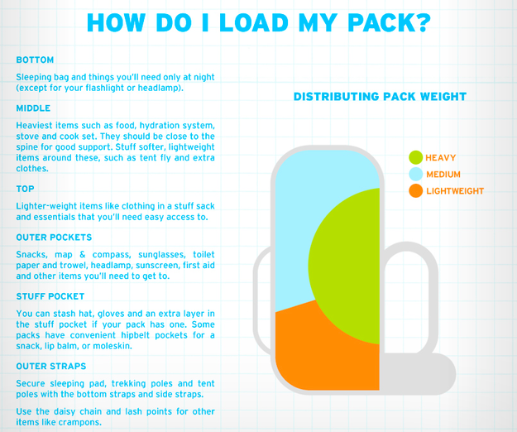
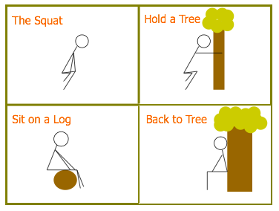
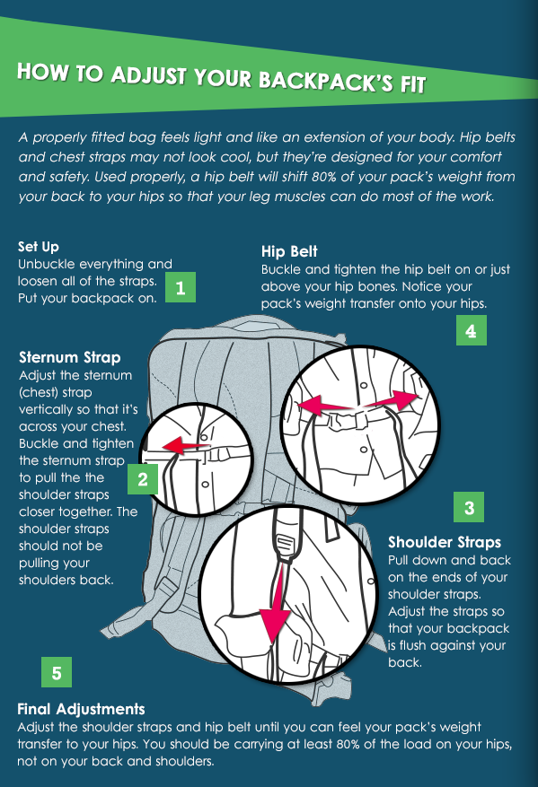
From tortugabackpacks.com
Leave NO Trace

As more and more people visit our forests and trails, many of our areas become overcrowded with people, and the evidence of people. Backcountry areas are places to seek solitude, and for those who value these places of escape, we ask they make a commitment to protect and preserve these areas. The Leave No Trace program has techniques that visitors can use to help reduce evidence of their presence.
These guidelines help protect the land, and lessen the sights and sounds of visitors to the Forest.
- Plan for small groups - travel with fewer than 10 people. Campsites for small groups are easier to find and harmonize better with the environment.
- Obtain information about the area, obtain a map, and plan your route. Check on local rules and regulations.
- Visit areas which are less popular, or come in the off-season.
- Repackage food, removing glass, and carry trash bags for litter pickup. The Charles C. Deam Wilderness currently bans glass and cans in that area.
- Carry a small trowel for burying human waste and digging a small firepit. Use the "cat method" for burying waste, digging a shallow hole and covering with 6-8 inches of dirt. Stay at least 200 feet from water sources.
- Leave what you find. Do not carry out artifacts, souveniers, fossils.
- Stay on trails and do not cut across switchbacks.
- Respect wildlife, view from a distance.
- Do all washing away from water sources as soap is a pollutant.
- Be prepared. Know what weather is predicted and be ready for extremes. A highly visible vest should be included in your pack for rescue in the event you become lost. Carry a signal mirror, a whistle, and warm clothing.
- Be responsible. Pack out what you pack in.
For more information, visit the Leave No Trace website at www.LNT.org

Lighting Storm:
If There’s No Shelter, Where Should I Go?
In the forest: | Retreat to a group of small trees surrounded by taller trees or find a dry, low area like a depression or ravine. Avoid lone trees and other tall objects as well as rocky outcrops and ledges.
In an open area: | Look for a dry, low-lying area such as a valley and become the smallest target possible. Do this by crouching down with your heels touching, head between the knees, and ears covered. Minimize your contact with the ground and do not lie down flat.
Anywhere outdoors: | You can take shelter in a car or other safe shelter, but not a tent. In all cases, avoid bodies of water and areas that have high flash flood potential.

Campfire Safety

How to Pick Your Spot
- DO NOT build a fire at a site in hazardous, dry conditions. DO NOT build a fire if the campground, area, or event rules prohibit campfires.
- FIND OUT if the campground has an existing fire ring or fire pit.
- If there is not an existing fire pit, and pits are allowed, look for a site that is at least fifteen feet away from tent walls, shrubs, trees or other flammable objects. Also beware of low-hanging branches overhead.
Note: in some areas digging pits are not allowed because of archaeological or other concerns. Find out the rules in your area please.

How to Build a Campfire
- Gather three types of wood
    - Tinder (small twigs, dry leaves or grass, dry needles)
    - Kindling (sticks smaller than 1" around)
    - Fuel (larger pieces of wood)
- Loosely pile a few handfuls of tinder in the center of the fire ring/pit
- Add kindling in one of these methods:
    - Tipi (Good for cooking)
Lay the kindling over the tinder like you're building a tent.
    - Cross (Perfect for a long-lasting campfire)
Crisscross the kindling over the tinder.
    - Lean-to (Good for cooking)
Drive a long piece of kindling into the ground at an angle over the tinder. Lean smaller pieces of kindling against the longer piece.
    - Log Cabin (Longest lasting campfire)
Surround your pile of tinder with kindling, stacking pieces at right angles. Top the "cabin" with the smallest kindling.
- Ignite the tinder with a match or lighter
- Wait until the match is cold, and discard it in the fire
- Add more tinder as the fire grows
- Blow lightly at the base of the fire
- Add kindling and firewood to keep the fire going
- Keep the fire small and under control

Maintaining Your Campfire
As you're enjoying your campfire, remember these safety tips:
- Once you have a strong fire going, add larger pieces of dry wood to keep it burning steadily
- Keep your fire to a manageable size
- Make sure children and pets are supervised when near the fire
- Never leave your campfire unattended
- Never cut live trees or branches from live trees

Extinguishing Your Campfire
When you're ready to put out your fire and call it a night, follow these guidelines:
- Allow the wood to burn completely to ash, if possible
- Pour lots of water on the fire, drown ALL embers, not just the red ones
- Pour until hissing sound stops
- Stir the campfire ashes and embers with a shovel
- Scrape the sticks and logs to remove any embers
- Stir and make sure everything is wet and they are cold to the touch
- If you do not have water, use dirt. Mix enough dirt or sand with the embers. Continue adding and stirring until all material is cool. Remember: do NOT bury the fire as the fire will continue to smolder and could catch roots on fire that will eventually get to the surface and start a wildfire.

REMEMBER: If it's too hot to touch, it's too hot to leave!
Don't burn dangerous things!
- never burn aerosol cans or pressurized containers. They may explode.
- never put glass in the fire pit. Glass does not melt away, it only heats up and shatters. Broken slivers of glass are dangerous.
- aluminum cans do not burn. In fact, the aluminum only breaks down into smaller pieces. Inhaling aluminum dust can be harmful to your lungs.
Pack it in, Pack it out.
- be sure to pack out your trash. It is your responsibility to pack out everything that you packed in.

Poison Ivy, Oak, or Sumac - Topic Overview

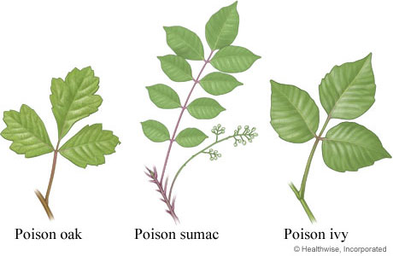
What are poison ivy, oak, and sumac?
Poison ivy, poison oak, and poison sumac are plants that can cause a skin rash called allergic contact dermatitis when they touch your skin. The red, uncomfortable, and itchy rash often shows up in lines or streaks and is marked by fluid-filled bumps (blisters) or large raised areas (hives). It is the most common skin problem caused by contact with plants (plant dermatitis).

What causes the rash?
The rash is caused by contact with an oil (urushiol) found in poison ivy, oak, or sumac. The oil is present in all parts of the plants, including the leaves, stems, flowers, berries, and roots. Urushiol is an allergen, so the rash is actually an allergic reaction to the oil in these plants. Indirect contact with urushiol can also cause the rash. This may happen when you touch clothing, pet fur, sporting gear, gardening tools, or other objects that have come in contact with one of these plants. But urushiol does not cause a rash on everyone who gets it on his or her skin.

What are the symptoms of the rash?
The usual symptoms of the rash are:
- Itchy skin where the plant touched your skin.
- Red streaks or general redness where the plant brushed against the skin.
- Small bumps or larger raised areas (hives).
- Blisters filled with fluid that may leak out.
The rash usually appears 8 to 48 hours after your contact with the urushiol. But it can occur from 5 hours to 15 days after touching the plant.¹ The rash usually takes more than a week to show up the first time you get urushiol on your skin. But the rash develops much more quickly (within 1 to 2 days) after later contacts. The rash will continue to develop in new areas over several days but only on the parts of your skin that had contact with the urushiol or those parts where the urushiol was spread by touching.
The rash is not contagious. You cannot catch or spread a rash after it appears, even if you touch it or the blister fluid, because the urushiol will already be absorbed or washed off the skin. The rash may seem to be spreading, but either it is still developing from earlier contact or you have touched something that still has urushiol on it.
The more urushiol you come in contact with, the more severe your skin reaction. Severe reactions to smaller amounts of urushiol also may develop in people who are highly sensitive to urushiol. Serious symptoms may include:
- Swelling of the face, mouth, neck, genitals, or eyelids (which may prevent the eyes from opening).
- Widespread, large blisters that ooze large amounts of fluid.
Taken from http://www.webmd.com/allergies/tc/poison-ivy-oak-or-sumac-topic-overview

